Abstract title (16pt, bold, align center, only first letter capitalized)
I. M. Author¹, A. D. Two², M. T. Three³ (12pt, bold, align center)
¹Institution address; E-mail: i.m.author@institution1.com (10pt, italic, align left)
²Institution address (10pt, italic, align left)
³Institution address (10pt, italic, align left)

The total size of the abstract should not exceed 1 page.
Abstract should be written in format A4, with the following 2 cm margins (Example et al., 2017).
Body text should be written using the font Times New Roman, 10pt, full justification (Reference, 2009).
The authors could include Figures, Tables, chemical reactions, diagrams, acknowledgements, etc.

Table 1. Zearalenone sorption by the zeolitic tuff modified with different amounts of ODMBA

Solid/liquid ratio  (mg/10 mL) | ZEN sorption index,%
 | OZ-2 |  |  | OZ-5 |  |  | OZ-10
 | pH 3 | pH 7 | pH 9 | pH 3 | pH 7 | pH 9 | pH 3 | pH 7 | pH 9
40 | 86 | 93 | 96 | 93 | 99 | 99 | 96 | 99 | 99
20 | 72 | 79 | 87 | 88 | 96 | 99 | 91 | 97 | 98
10 | 56 | 66 | 68 | 79 | 82 | 90 | 78 | 88 | 92
4 | 34 | 37 | 33 | 59 | 52 | 60 | 56 | 65 | 80

Figure caption. 9 point, align left, at bottom of figure.

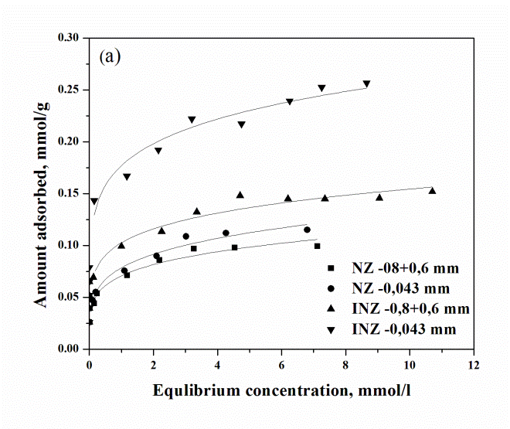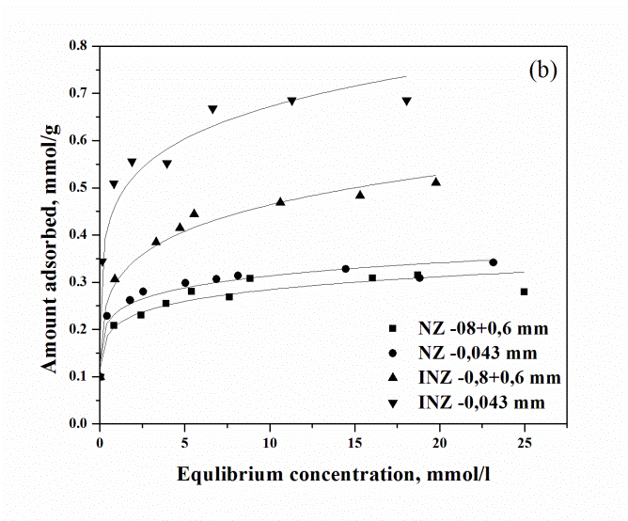
Figure 1. Sorption of (a) copper and (b) lead by NZ and INZ

Acknowledgments (10pt, bold, align left)

References (10pt, align left)
Example, A. N., Chemistry, C., Inorganic, M., Journ. Name 53, 1256 (2017).
Reference, B. P., Rev. Name 36, 7648 (2009).

