

REGISTRATION FORM

Title / Position _________________________________________________________________________________
First name and Family name ______________________________________________________________________
Country ________________________________________________________________________________________
Affiliation ______________________________________________________________________________________
Address _______________________________________________________________________________________
City _____________________________________________ Postal code _______________________________
Tel: _____________________________________________ Fax: _____________________________________
E-mail: _____________________________________________
Accompanying person
Family & First name ____________________________________________________________________________

participation options

Regular participant □ Accompanying person □

Section number □

PAYMENT

Registration fee payments could be made by bank transfer

EURO account: IBAN RO82 BRDE 240S V189 8316 2400 (SWIFT: BRDE ROBU)
RON account: IBAN RO20 BRDE 240S V077 0136 2400

ASOCIATIA ABSOLVENTILOR FACULTATII DE CHIMIE INDUSTRIALA IASI, BRD Iasi,
Agentia Campus Tudor, Tax code - 13792743

Please include your name and the reference "Conference ICCE2014"

Date: Signature:

Abstract

Abstract title (16pt, bold, align left, only first letter capitalized)
I. M. Author¹, A. D. Two², and M. T. Three³ (12pt, bold, align left)
¹Institution address; E-mail: i.m.author@institution1.com (10pt, italic, align left)
²Institution address (10pt, italic, align left)
³Institution address (10pt, italic, align left)

The total size of the abstract should not exceed 1 page.
Abstract should be written in format A4, with the following 2 cm margins.
Body text should be written using the font Times New Roman, 10 pt, full justification.
The authors could include Figures , Tables, chemical reactions, diagrams, acknowledgements, etc.

Table 1. Zearalenone sorption by the zeolitic tuff modified with different amounts of ODMBA

 | ZEN sorption index,%
 | OZ-2 |  |  | OZ-5 |  |  | OZ-10
Solid/liquid ratio  (mg/10 mL) | pH 3 | pH 7 | pH 9 | pH 3 | pH 7 | pH 9 | pH 3 | pH 7 | pH 9
40 | 86 | 93 | 96 | 93 | 99 | 99 | 96 | 99 | 99
20 | 72 | 79 | 87 | 88 | 96 | 99 | 91 | 97 | 98
10 | 56 | 66 | 68 | 79 | 82 | 90 | 78 | 88 | 92
4 | 34 | 37 | 33 | 59 | 52 | 60 | 56 | 65 | 80

Figure caption. 9 point, align left, at bottom of figure.

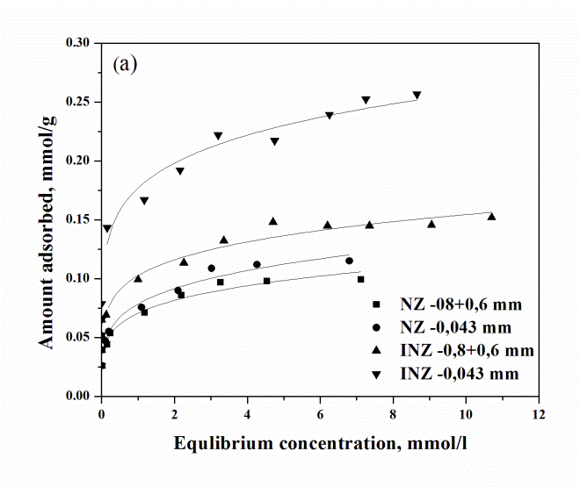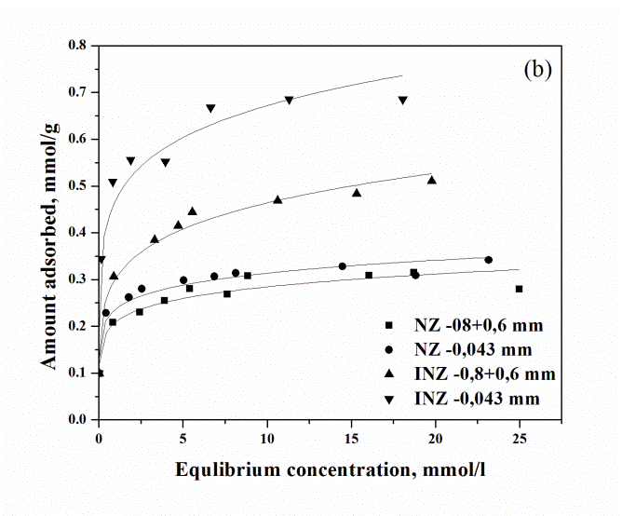
Figure 1. Sorption of (a) copper and (b) lead by NZ and INZ

Acknowledgments (10pt, bold, align left)

