Centenary of Education in Chemical Engineering Abstract template

Title: Bold Times New Roman 12 pt font
Johan Author¹*, Anna Author²
1 – Affiliation 1 with address
2 – Affiliation 2 with address
* corresponding author@email.com
Please underline the presenting author

An abstract of about 300 words in English language must be sent through the conference website no later than May 1, 2012. Abstracts should summarize results to be presented and be sufficiently descriptive to allow the Scientific Committee to judge the quality of the work and suitability for presentation at the conference.
Authors will be informed on acceptances of the lecture by May 30, 2012.

References to prior literature may be included [1] as footnotes. Tables, graphs and illustrations may be valuable in evaluating the abstracts.

The abstracts will not be published in the conference proceedings issue, but will be provided to conference attendees in the Conference Program and will be available prior to the conference webpage. The Conference Program will be printed in black and white (black and white figures are preferred).

Example figures are shown below.
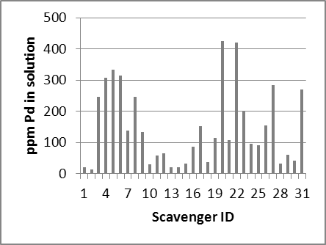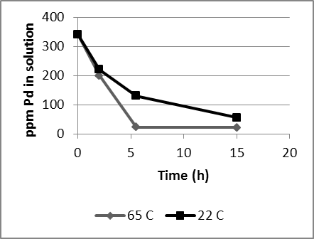

Figure 1. Caption text is not bold Figure 2. Caption

Example references
[1] A.O. King and N. Yasuda, Top. in Organomet. Chem. 6 (2004) 205.
[2] A.M. Bradshaw in: Surface and Defect Properties of Solids, Vol. 3, eds. M.W. Roberts and J.M.Thomas (The Chemical Society, London, 1974) ch. 5.

